Assembly of XYZ Stage

This document should explain a step by step guide on how to build the XYZ-stage for the UC2.

Benedict Diederich

V0; Date

## Table of Content

Table of Content 2

Motivation 3

Goals 4

Full Setup 4

Bill of Materials 5

3D Printing 8

Assembly 8

1st Step – Get the parts ready 8

2nd Step Mount the stepper and the gears 9

3rd Step – Observe Result 9

4th Step – Mount Z-Motor in the Cube with M3 Screws 10

5th Step – Get the cables ready 10

6th Step – Observe the result 11

7th Step – Mount the XY Microstepper on the adapter plate 11

8th Step – Put/Hide the electronics inside the cube and mount the Arduino in its place 12

8th Step – Put everything in place and mount the slide-mount, Use magnetic (!) screws 12

Software 13

Resources 13

Links 13

# Motivation

* In Microscopy one usual needs to scan a ROI (Region of Interest), because the FOV (Field of view of an microscope objective lens is too small)
* We will do that by scanning the sample in X and Y
* In Z one usually needs to manipulate the objective lens to focus/refocus the image on the detector
* We will do that by adjusting the Z-position of the objective lens

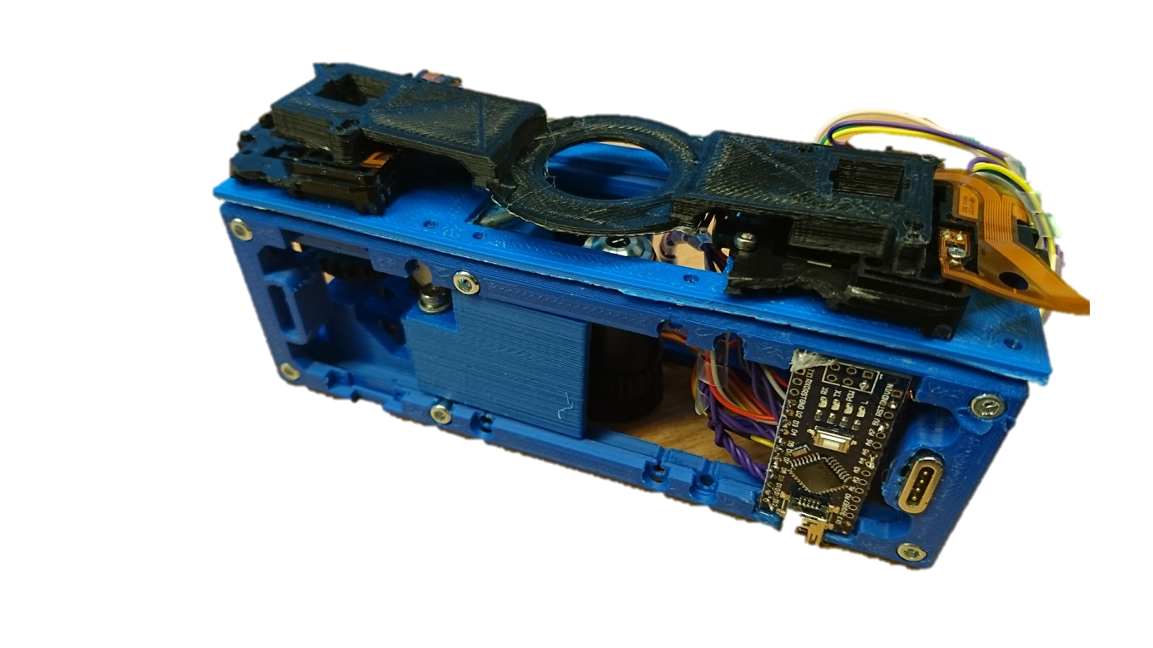

**Z**

**Y**

**X**

Figure 1: Fully functional XYZ-Stage based ready to use for the I2C-equipped UC2 System

Goals  
This guide tells you:

* Which parts are necessary?
* Buy the parts?
* How to print the parts?
* How to assemble the parts?
* How to get the software ready to make it work?

# Full Setup

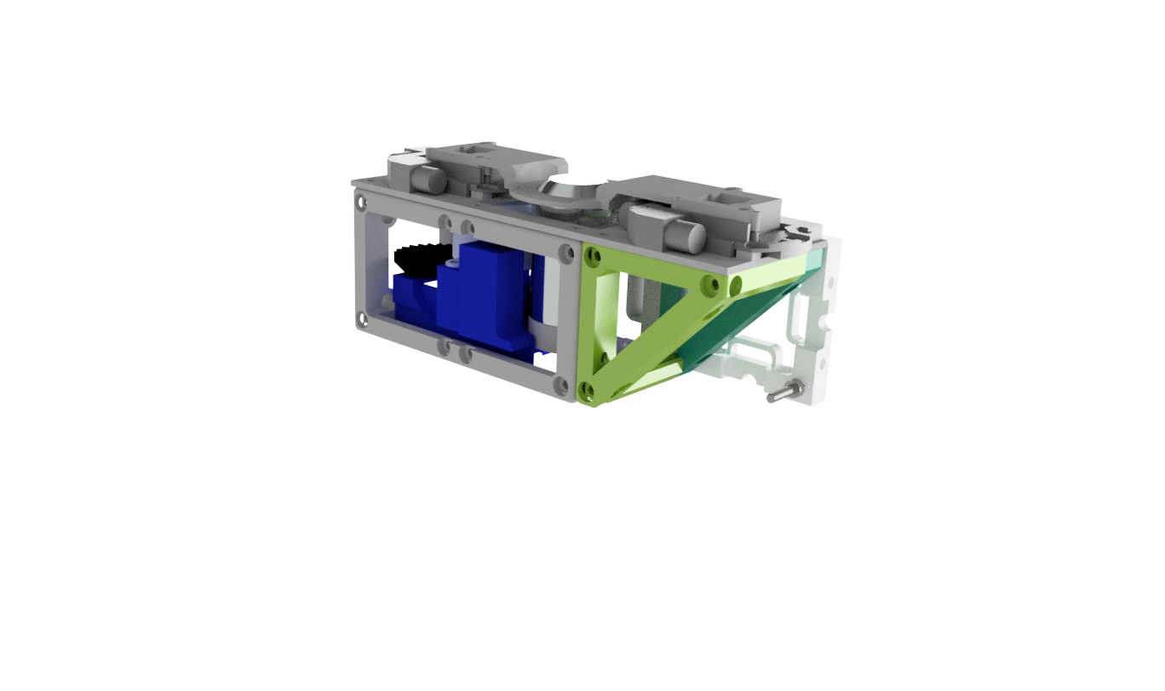

XY Microstepper

Objective Lens + Slide

Slide Carrier

XY Microstepper

Flexure-Bearing Z-Focus

Gear (large)

Gear (small)

Adapter Plate

3x1 Cube

Stepper Motor

3x1 Cube (lid)

Arduino Nano

Figure 2 – This is how it should look like once it’s ready.

# Bill of Materials

|  |  |  |  |
| --- | --- | --- | --- |
| Quantity | Description/Name | Image | Price |
| 2 | Microstepper XY-Stage   * <https://www.aliexpress.com/item/Micro-stepping-motor-cross-platform-small-mobile-digital-microscope-XY-axis-table-experiment-two-slide/32790147861.html> | Micro stepping motor cross platform small mobile digital microscope XY axis table experiment two slide | 3€ |
| 1 | 28BYJ-48 ULN2003 5V Stepper Motor + ULN2003 Driver Board for Arduino   * <https://www.amazon.com/ELEGOO-28BYJ-48-ULN2003-Stepper-Arduino/dp/B01CP18J4A/ref=asc_df_B01CP18J4A/?tag=hyprod-20&linkCode=df0&hvadid=312106041990&hvpos=1o2&hvnetw=g&hvrand=188168084368003844&hvpone=&hvptwo=&hvqmt=&hvdev=c&hvdvcmdl=&hvlocint=&hvlocphy=9001989&hvtargid=pla-567948185662&psc=1&tag=&ref=&adgrpid=62149807356&hvpone=&hvptwo=&hvadid=312106041990&hvpos=1o2&hvnetw=g&hvrand=188168084368003844&hvqmt=&hvdev=c&hvdvcmdl=&hvlocint=&hvlocphy=9001989&hvtargid=pla-567948185662> | Bildergebnis fÃ¼r 28ybj-48 | 3€ |
| 1 | Arduino Nano (equivalent)   * <https://www.amazon.com/HWAYEH-Arduino-Nano-V3-0-Micro-Controller/dp/B07D6TM4Y1/ref=pd_day0_hl_147_6?_encoding=UTF8&pd_rd_i=B07D6TM4Y1&pd_rd_r=f06b6c14-f83f-11e8-b5bc-bd52b7fe7240&pd_rd_w=1iWt8&pd_rd_wg=oXyNT&pf_rd_i=desktop-dp-sims&pf_rd_m=ATVPDKIKX0DER&pf_rd_p=ad07871c-e646-4161-82c7-5ed0d4c85b07&pf_rd_r=9CHF5YAP4GA0M9MN9ZD0&pf_rd_s=desktop-dp-sims&pf_rd_t=40701&psc=1&refRID=9CHF5YAP4GA0M9MN9ZD0> | HWAYEH for Arduino Nano V3.0, Nano Board CH340/ATmega328P 5V 16M Micro-Controller Board with USB Cable, Compatible with Arduino Nano V3.0 (Nano x 1 + Cable) | 3€ |
| 1 | Stepper Driver 8833, 2 Kanal DRV8833 DC Motor Driver Modul 3V-10V 1.5A H-Bridge Für Arduino  <https://www.ebay.de/itm/263933082352> | https://i.ebayimg.com/images/g/Zx8AAOSwJFhbmTVI/s-l1600.jpg |  |
| 16 | Schrauben (DIN 912, M3, 18mm, kein Edelstahl! Müssen magnetisch sein-> Eisen!)   * <https://www.conrad.de/de/toolcraft-839670-zylinderschrauben-m3-12-mm-innensechskant-din-912-iso-4762-stahl-88-geschwaerzt-100-st-839670.html> |  | 1€ |

The following parts can be downloaded from the Github repo /CAD/XYZ-Stage

|  |  |  |  |
| --- | --- | --- | --- |
| Quantity | Description/Name | Image | Price |
| 1 | 1x3 Cube (lower part) |  | 3€ |
| 1 | 1x Cube (electric-lid) |  | 3€ |
| 1 | 1x Flexure Bearing Z-Focusing Mechanism |  | 3€ |
| 1 | Adapter Plate |  | 3€ |
| 1 | Slide Mount |  | 3€ |
| 1 | Gear (Large)  Borrowed from R. Bowman |  | 3€ |
| 1 | Gear (Small)  Borrowed from R. Bowman |  | 3€ |

# 3D Printing

All “.stl” files in the folder /CAD/XYZ-Stage should be downloaded and printed. Don’t be confused by the CAD model above, we updated it to make it easier to assemble. We printed with an Ultimaker 2+ with a 0.4 Nozzlesize. Printing settings: Default at medium quality (0.1mm layer height) and Avistron ABS. Use the glue stick to make sure the first layer sticks! Don’t use BRIM or any other adhesion techniques!

# Assembly

Below you’ll find a step-by-step guide on how we assembled it. If you’re lacking any additional steps, please don’t hesitate to file an issue. We’re willing to help!

## 1st Step – Get the parts ready

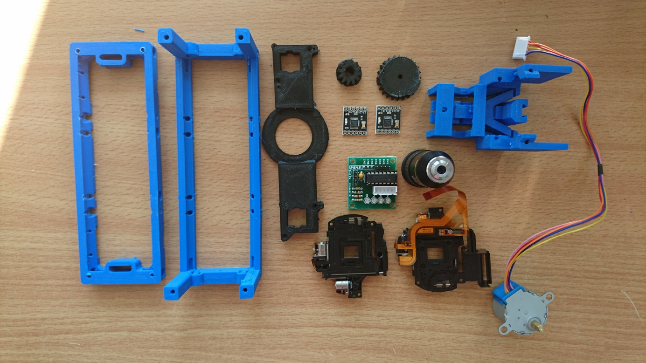

## 2nd Step Mount the stepper and the gears

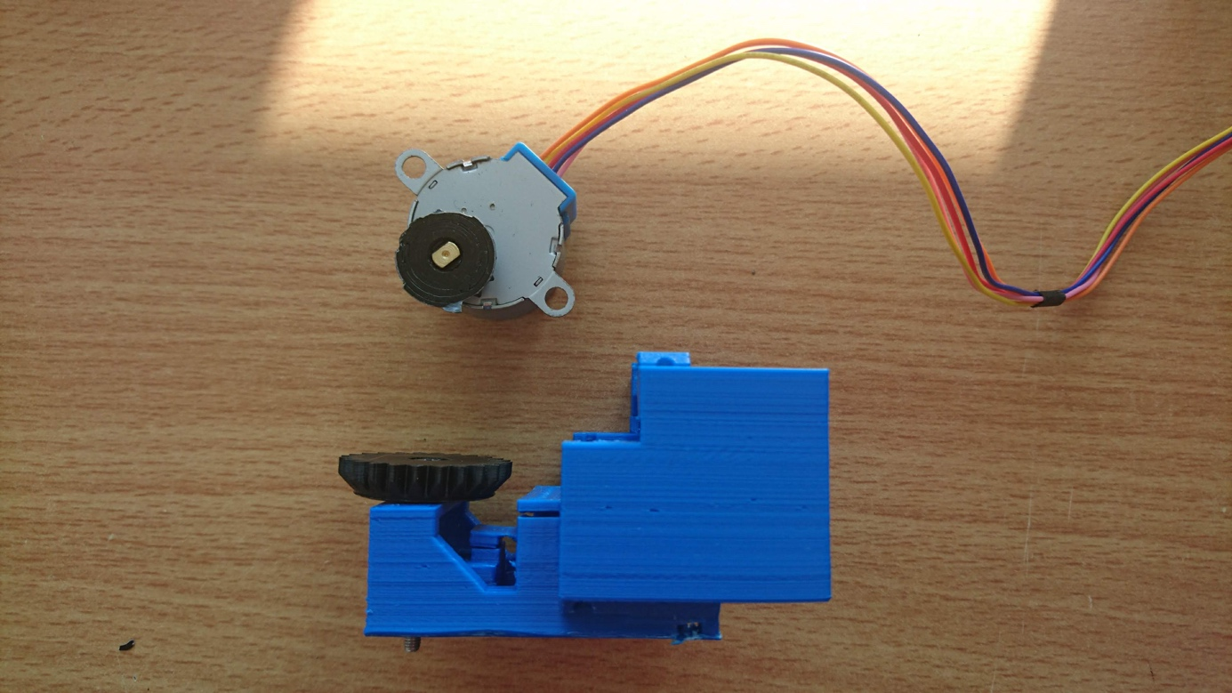

Optional: Place a spring between the gear and the level-arm so that it gets back in the rest position easier.

## 3rd Step – Observe Result

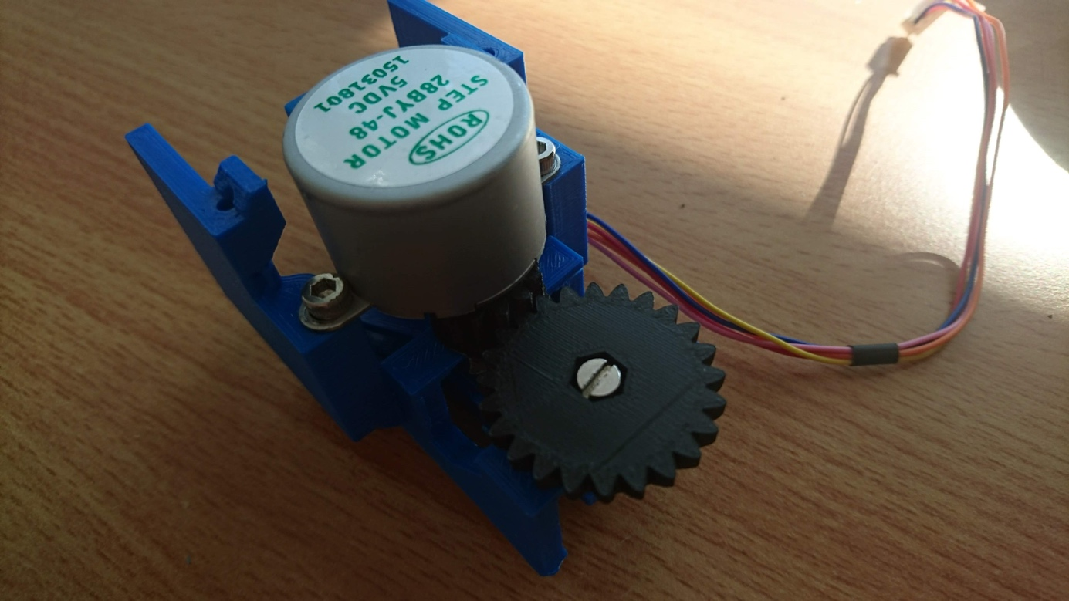

Advice: The Gear turns the screw and the nut (glued) to the level arm acts like a worm-drive pulling the level-arm up and down.

## 4th Step – Mount Z-Motor in the Cube with M3 Screws

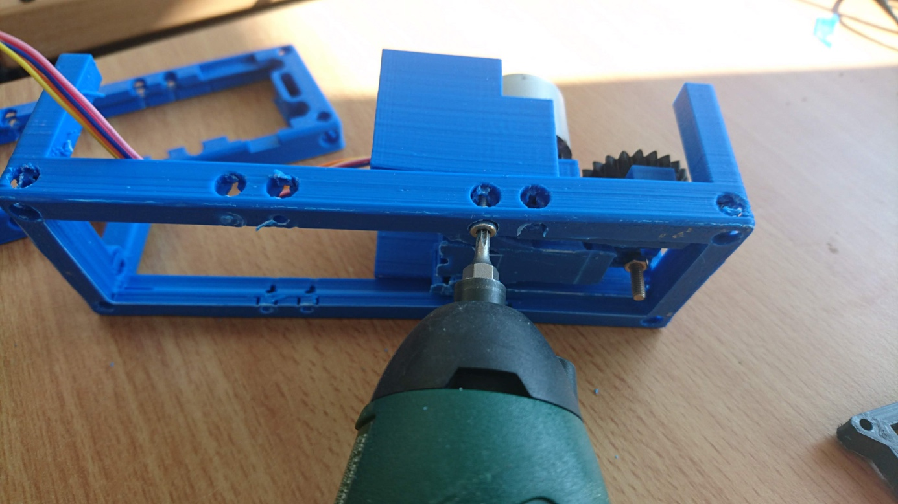

## 5th Step – Get the cables ready

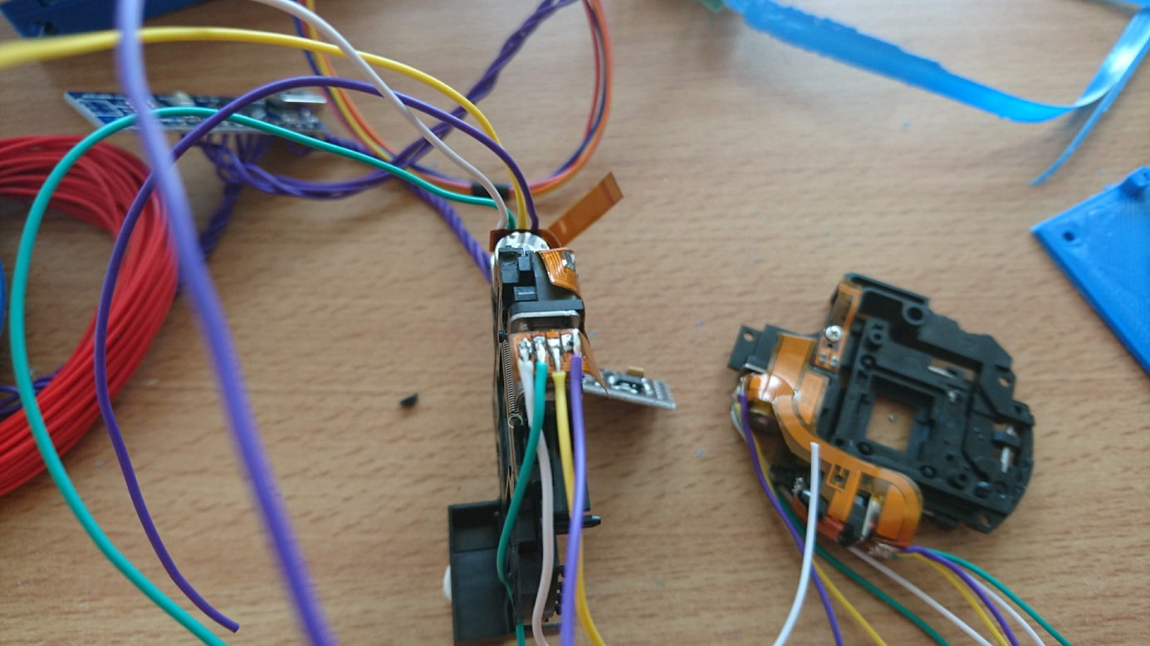

This follows the guide in our electronics section. You need two XY Microstepper, the 28-Y Motor and its driver. All connects to the Arduino and a 5V power source which is coming from the I2C wires.

## 6th Step – Observe the result

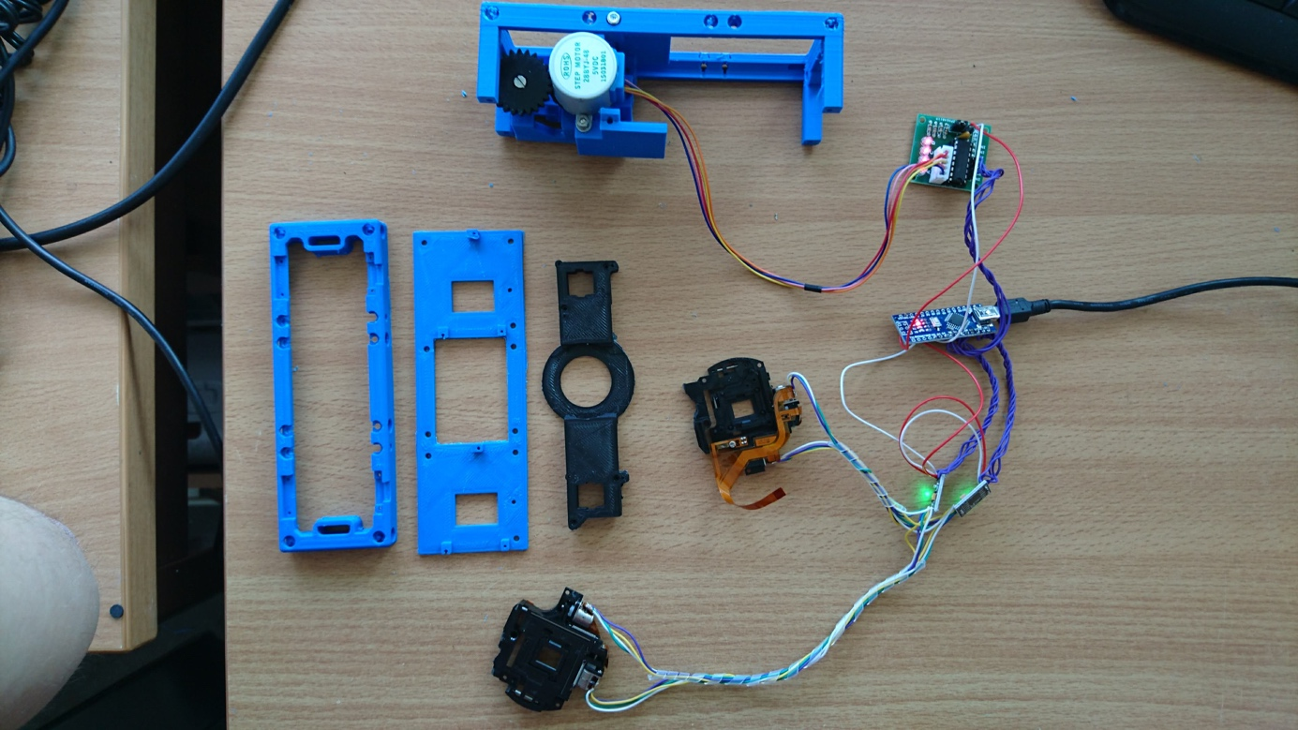

## 7th Step – Mount the XY Microstepper on the adapter plate

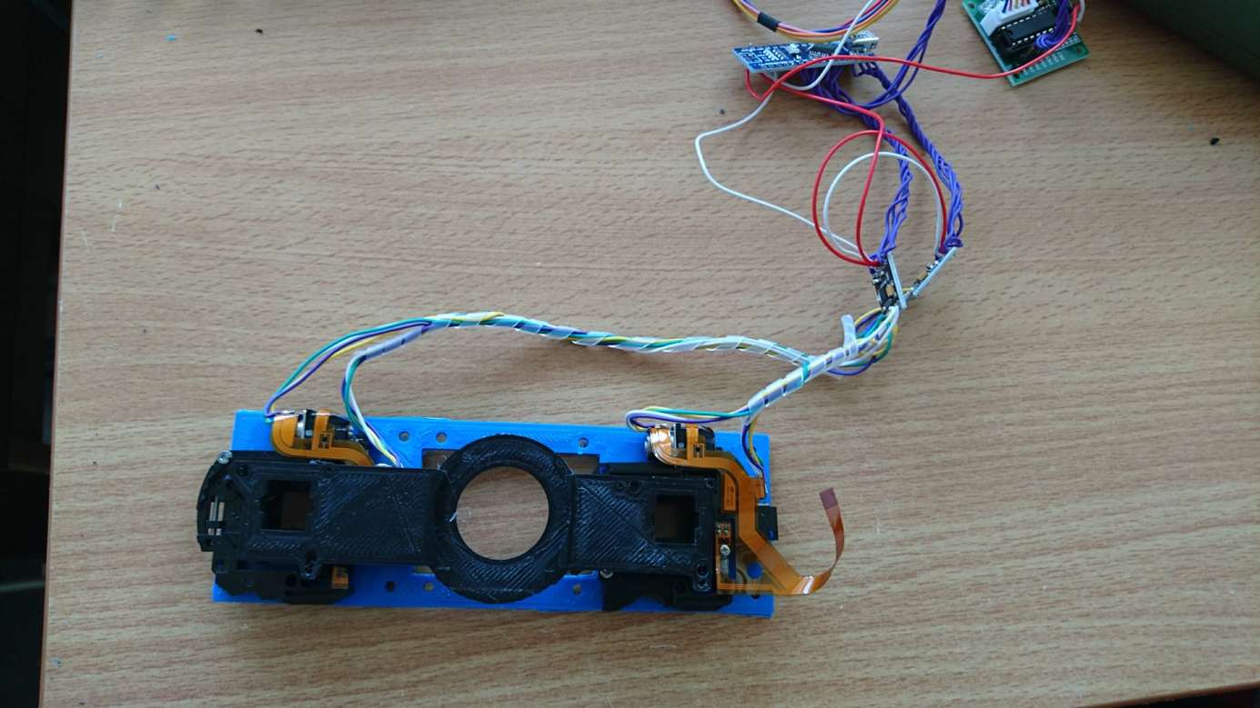

The slide-adapter (black) can be placed on the XY-Microsteppers via a press-fit mechanism. Depending on the printers precision, one has to modify the part a bit or simply glue it with hot-glue.

## 8th Step – Put/Hide the electronics inside the cube and mount the Arduino in its place

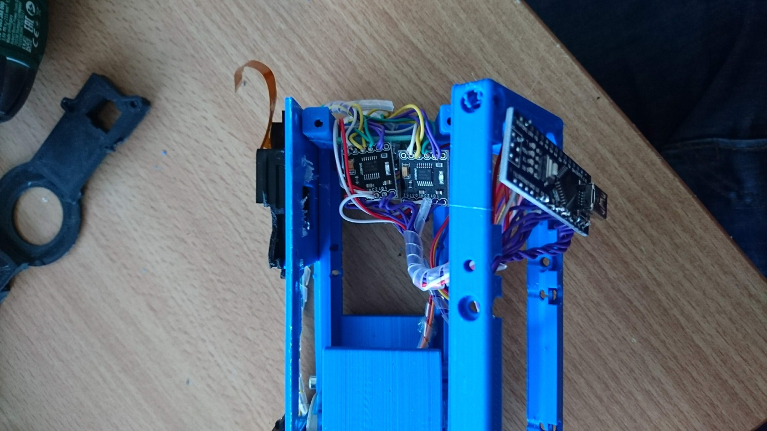

Advice: Pack the cables tightly together!

## 8th Step – Put everything in place and mount the slide-mount, Use magnetic (!) screws

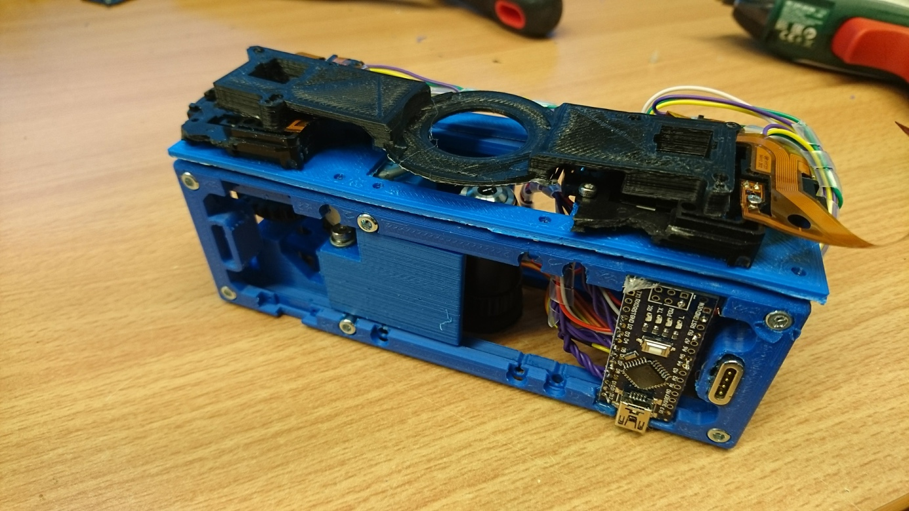

Tadah! If you made it this far, you’re simply great! Take a break!

# Software

Please download the motor.ino from the Software folder and flash it to the Arduino. If everything went right, it should work like a charm.

# Resources

## Links

<https://www.waterscope.org/wp-content/uploads/OpenFlexure-microscope-assembly-instructions.pdf>